Final Web ui to search:

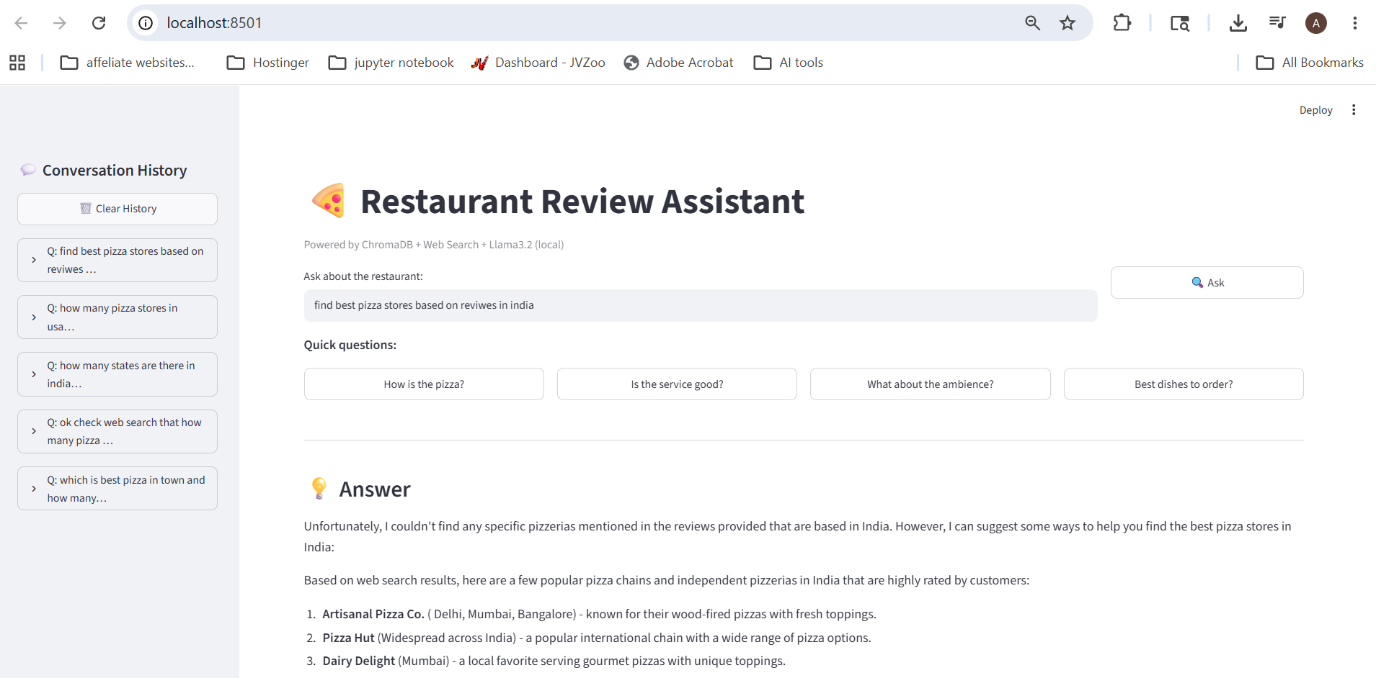

Data in persistent memory can be seen in sqllite
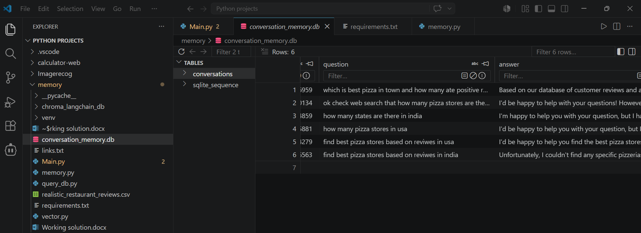

Vector in Chorma DB
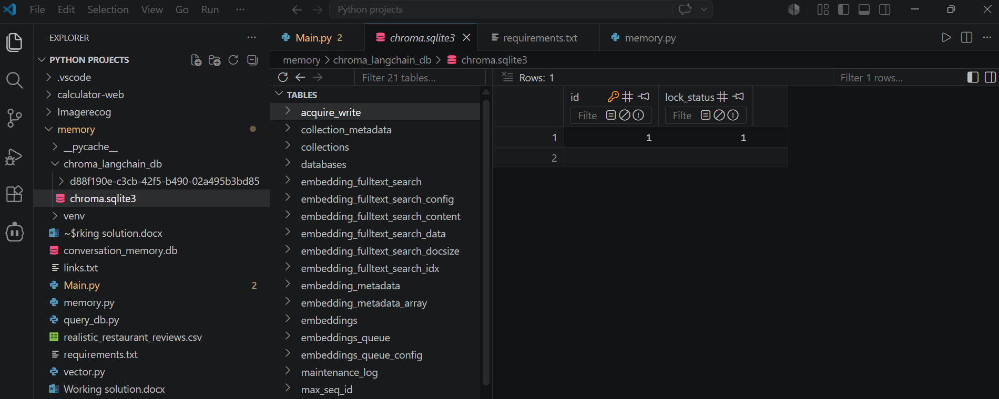

DuckDuckGo and Tavily used for web search
realistic_restaurant_reviews csv file for RAG search

